**AIR QUALITY MONITORING**

**PHASE-4 DOCUMENT SUBMISSION**

**TEAM MEMBERS :**

**DHINESH M**

**LAL PRASATH L**

**SABARESHWARAN G**

**BALA ARUN R**

**PROJECT:** AIR QUALITY MONITORING

**PHASE 4 :** DEVELOPMENT PART 2

**INTRODUCTION**

Air quality monitoring means checking the air to see if it's clean or polluted. We use special machines to measure things in the air, like dust, gases, and tiny particles. This helps us know if the air is safe to breathe. If it's not safe, we can take steps to make it cleaner and protect our health. Air quality monitoring is important because clean air is better for us and the environment

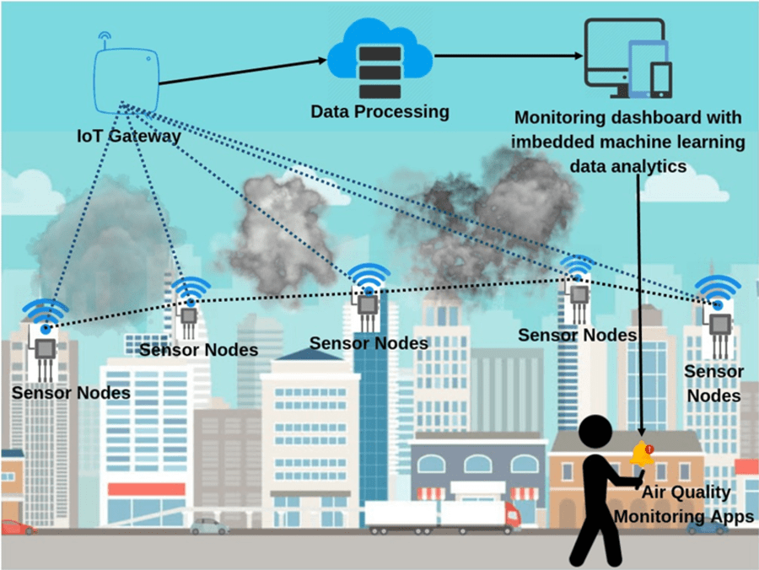

**SOFTWARE AND FIRMWARE**

**1. *Conceptualization and Planning*:**

**- Define the goals and requirements for your air quality monitoring system.**

**- Determine the target platform for your mobile app (iOS, Android, or both).**

**- Decide on the hardware components needed for the monitoring device.**

**2. *Hardware Development*:**

**- Choose the appropriate sensors for monitoring air quality (e.g., particulate matter sensors, gas sensors).**

**- Design the hardware circuit and PCB (Printed Circuit Board) layout.**

**- Develop the firmware for the microcontroller or embedded system that interfaces with the sensors and transmits data.**

**3. *Software Development*:**

**- Mobile App:**

**- For Android, you can use Android Studio with Java or Kotlin.**

**- For iOS, you can use Xcode with Swift.**

**- Consider using cross-platform development tools like Flutter or React Native to target both Android and iOS simultaneously.**

**- Implement features such as real-time data visualization, historical data storage, and user-friendly interfaces.**

**- Integrate features like user registration, login, and push notifications.**

**4. *Data Management*:**

**- Set up a cloud-based database (e.g., Firebase, AWS, or Azure) for storing air quality data.**

**- Implement secure communication between the device and the database for data synchronization.**

**5. *User Interface (UI) and User Experience (UX)*:**

**- Use design tools like Figma, Adobe XD, or Sketch to create wireframes and design mockups.**

**- Ensure a user-friendly and intuitive interface for the mobile app.**

**6. *Connectivity*:**

**- Establish communication protocols between the monitoring device and the mobile app, such as Bluetooth, Wi-Fi, or cellular networks.**

**- Implement secure data transfer to prevent unauthorized access.**

**7. *Testing*:**

**- Thoroughly test the hardware and firmware to ensure the accuracy of air quality measurements.**

**- Test the mobile app for usability, stability, and compatibility with different devices and operating systems.**

**8. *Deployment*:**

**- Publish the mobile app on the Google Play Store (for Android) and Apple App Store (for iOS).**

**- Provide clear user instructions on how to set up and use the monitoring device and the mobile app.**

**9. *Maintenance and Updates*:**

**- Regularly update both the mobile app and firmware to improve functionality, security, and compatibility.**

**10. *Compliance and Regulations*:**

**- Ensure that your air quality monitoring device complies with relevant regulations and standards, such as safety and emissions standards.**

**11. *Documentation and Support*:**

**- Create user manuals and documentation for your device and app.**

**- Offer customer support for troubleshooting and inquiries.**

**12. *Data Analysis and Reporting*:**

**- Implement data analysis and visualization tools to provide users with insights and trends in air quality data.**

**HARDWARE COMPONENTS**

**1. *User Interface (UI):\***

**- *Dashboard:* A clean and intuitive dashboard that provides an overview of key air quality metrics, such as AQI (Air Quality Index), pollutant levels (PM2.5, PM10, CO, NO2, etc.), and weather conditions.**

**- *Maps:* An interactive map interface with color-coded markers or overlays to display air quality levels in different areas. Users can zoom in and out for a more detailed view.**

**- *Graphs and Charts:* Time-series charts showing historical air quality data, allowing users to track trends and changes over time.**

**2. *User Experience (UX):\***

**- *Onboarding:* An easy-to-follow onboarding process to help users set up the app, choose their location, and customize preferences.**

**- *Notifications:* Push notifications to alert users about air quality changes, alerts, or advisories for their selected locations.**

**- *Geolocation:* Use the device's GPS to provide real-time air quality information for the user's current location.**

**- *Search:* A search feature for users to look up air quality information in different cities or regions.**

**3. *Data Sources:\***

**- *API Integration:* Connect to reliable air quality monitoring APIs or data sources to fetch accurate and up-to-date information.**

**- *Weather Data:* Integrate weather APIs to provide additional context for air quality conditions.**

**4. *Air Quality Information:\***

**- *AQI Scale:* Clearly explain the Air Quality Index (AQI) scale, its meaning, and the associated health risks.**

**- *Pollutant Details:* Provide detailed information about specific pollutants, their sources, and health effects.**

**- *Recommendations:* Offer health recommendations based on the current air quality, such as staying indoors, wearing masks, or avoiding outdoor activities.**

**5. *Customization and Preferences:\***

**- *Location Selection:* Allow users to save and switch between multiple locations for monitoring.**

**- *Alert Thresholds:* Let users set their preferred air quality alert thresholds to receive notifications when specific conditions are met.**

**- *Unit Preferences:* Provide options for users to select their preferred units (e.g., µg/m³, ppm, °C, °F).**

**6. *Historical Data:\***

**- *Date Selection:* Allow users to view historical air quality data for different dates.**

**- *Graphs and Trends:* Display historical data in interactive charts and graphs for easy analysis.**

**7. *Accessibility and Inclusivity:\***

**- Ensure the app is accessible to users with disabilities, following best practices for screen readers and voice commands.**

**8. *Offline Mode:\***

**- Provide basic functionality and cached data for users without an internet connection.**

**9. *Settings and About Page:\***

**- Include a settings menu to customize app behavior, including notification preferences, location services, and data source information.**

**- An "About" or "Info" section with details about the app, data sources, and contact information.**

**10. *Privacy and Security:\***

**- Implement robust security measures to protect user data and ensure privacy compliance, especially when dealing with location data.**

**11. *Feedback and Support:\***

**- Include a feedback mechanism for users to report issues, suggest improvements, or seek assistance.**

**- Offer customer support contact information or chat support for user inquiries.**

**12. *App Design Guidelines:\***

**- Adhere to platform-specific design guidelines (e.g., Material Design for Android, Human Interface Guidelines for iOS) for a consistent and familiar user experience.**

**MOBILE APP DEVELOPMENT**

**1. *Set Up Your Node.js Environment*:**

**Ensure you have Node.js and npm (Node Package Manager) installed on your server or development environment.**

**2. *Initialize a Node.js Project*:**

**Run the following command to create a new Node.js project and generate a `package.json` file.**

**bash**

**npm init**

**Follow the prompts to set up your project details.**

**3. *Install Required Packages*:**

**You'll need various packages to set up your backend, including Express for creating APIs and a database library if you plan to store data. Install them using `npm`:**

**bash**

**npm install express mongoose**

**- `express` is a popular web application framework.**

**- `mongoose` is a library for MongoDB, a NoSQL database commonly used for such applications.**

**4. *Create an Express App*:**

**Create a JavaScript file (e.g., `app.js`) and set up your Express application:**

**javascript**

**const express = require('express');**

**const app = express();**

**const port = process.env.PORT || 3000;**

**app.use(express.json());**

**// Define routes for your API here**

**// Example: app.get('/api/airquality', (req, res) => { /* Handle air quality data here */ });**

**app.listen(port, () => {**

**console.log(`Server is running on port ${port}`);**

**});**

**5. *Define Routes and Logic*:**

**Define routes to handle data from your air quality monitoring device and manage user accounts. This is where you handle data processing, storage, and retrieval. Use appropriate data models and database connections (e.g., using Mongoose for MongoDB).**

**6. *Authentication and Security*:**

**Implement user authentication and security measures to protect your API endpoints and user data.**

**7. *Testing and Debugging*:**

**Test your backend thoroughly to ensure it handles requests correctly and securely.**

**8. *Deployment*:**

**Deploy your Node.js backend to a server or cloud platform (e.g., AWS, Heroku) to make it accessible to your mobile app.**

**9. *Logging and Monitoring*:**

**Implement logging and monitoring solutions to track server performance and errors.**

**10. *Scaling*:**

**As your app grows, consider implementing scalability measures to handle increased traffic and data volume.**

**JAVA SCRIPT FOR AIR QUALITY MONITORING**

**javascript**

**// Simulated air quality data (replace with actual data)**

**const airQualityData = {**

**aqi: 75,**

**pollutant: "PM2.5",**

**};**

**// Function to update the displayed air quality data**

**function updateAirQualityDisplay() {**

**const aqiValue = document.getElementById("aqi-value");**

**aqiValue.textContent = `AQI: ${airQualityData.aqi} (Pollutant: ${airQualityData.pollutant})`;**

**}**

**// Simulate updating air quality data every 5 seconds**

**setInterval(() => {**

**// Fetch and update air quality data from your device or API**

**// For this example, we'll use the simulated data**

**airQualityData.aqi = Math.floor(Math.random() * 101); // Random AQI value**

**airQualityData.pollutant = "PM2.5"; // Simulated pollutant**

**// Update the display**

**updateAirQualityDisplay();**

**}, 5000);**

**// Initial update of air quality data**

**updateAirQualityDisplay()**

**OUT PUT :**

**AQI: 75 (Pollutant: PM2.5)**

**AQI: [Random AQI Value] (Pollutant: PM2.5)**